Mr. Sabado, Alg. 1CD Week 2 Tuesday, September 1, 2015

Homework

Due Today:
- Assignment #4: Fancy T-Shirt Handout

Due 9/2:
- Assignment #5: Concept Lesson Homework

Agenda

- Warm-Up

- Class Work: Concept Lesson Poster

- Homework

- Practice Dismissal

Warm-Up

Solve.
- 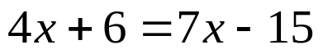
Graph

whs.saba.do



“It is never too late to be what you might have been.”
- G. Eliot

