Mr. Sabado, Alg. 1CD Week 2 Friday, September 4, 2015

Homework

Due Today:
- Assignment #7: Graphing Inequalities
- Opener Packet

Due 9/8:
- EC: Graphing
- Opener Packet

Quiz Today!!!

Agenda

- Warm-Up
- HW Questions
- Turn in Packet

- Quiz

- Poster Grades

- Quiet Activity

- Practice Dismissal

Warm-Up

Simplify the following when w = 4 and z = 2
- 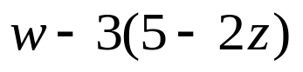
2)
Graph 3x + 2y < 8

whs.saba.do



“It is never too late to be what you might have been.”
- G. Eliot

