Mr. Sabado, Alg. 1CD Week 3 Tuesday, September 8, 2015

Homework

Due Today:
- EC: Graphing

Due 9/8:
- Unfinished Class Work

Quiz Friday!!!

Agenda

- Warm-Up

- Lesson: Graphing Systems

- Class Work

- Homework

- Practice Dismissal

Warm-Up

Simplify the following when (4, -5)
- 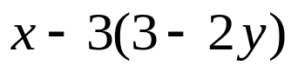
- 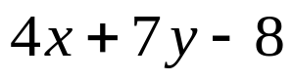

whs.saba.do



“It is never too late to be what you might have been.”
- G. Eliot

