Mr. Sabado, Alg. 1CD Week 3 Wednesday, September 9, 2015

Homework

Due Today:
- Assignment #8: 9/8 Class Work Handout

Due 9/10:
- Assignment #9:
Graphing Worksheet #1-8

Quiz Friday!!!

Agenda

- Warm-Up
- HW Questions

- Review: Graphing Systems

- Class Work

- Homework

- Practice Dismissal

Warm-Up

Graph the following
- 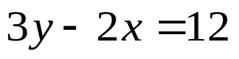
- 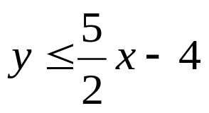

whs.saba.do



“It is never too late to be what you might have been.”
- G. Eliot

