Mr. Sabado, Algebra 2 Week 2 Thursday, September 3, 2015

Homework

Due Today:
- Assignment #7: Single Transformations

Due 9/4:
- Assignment #8: Function Families
- Opener Packet Due

Algebra 2 Online Textbook: 2606518-10
classzone.com

Agenda

- Warm-Up
- HW Questions

- Lesson Continued: Transformations & Parent Functions

- Class Work

- Homework

- Practice Dismissal

Warm-Up
Graph the following:
- 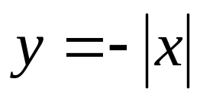

2. 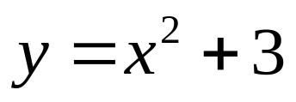

whs.saba.do



“It is never too late to be what you might have been.”
- G. Eliot

