Mr. Sabado, Algebra 2 Week 2 Friday, September 4, 2015

Homework

Due Today:
- Assignment #8: Function Families
- Opener Packet Due

Due 9/8:
- Assignment #9: Transformations Review

Algebra 2 Online Textbook: 2606518-10
classzone.com

Agenda

- Warm-Up
- HW Questions
- Turn in Opener Packet

- Review: Transformations & Parent Functions

- Homework

- Exit Ticket

Warm-Up
Graph the following:
- 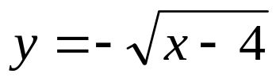

2. 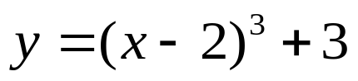

whs.saba.do



“It is never too late to be what you might have been.”
- G. Eliot

