Mr. Sabado, Algebra 2 Week 3 Wednesday, September 9, 2015

Homework

Due Today:
- Assignment #10: Function Families

Due 9/10:
- Assignment #11: Function Families:
Add Intervals of Increase, Decrease, Max, & Min

Algebra 2 Online Textbook: 2606518-10
classzone.com

Agenda

- Warm-Up
- HW Questions

- Lesson: Increase, Decrease, Max & Min

- Class Work

- Exit Ticket

Warm-Up
Determine the Domain and Range of :
- 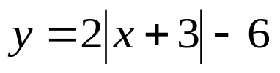
2. 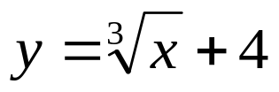

whs.saba.do



“It is never too late to be what you might have been.”
- G. Eliot

