Mr. Sabado, Algebra 2 Week 19 Tuesday, June 9, 2015

Home Practice

Due Today:
Assignment #70:
Trig Functions Worksheet

Due 6/10:
Assignment #71:
Unit 7 Review:


Agenda

- Warm-Up

- Review: Unit 7 Rational Expressions

- Work Period

- Homework

- Finals Extra Credit

- Return Graded Work

Warm-Up

Simplify
1. 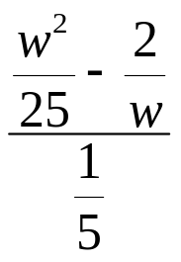

2. 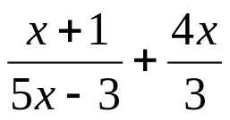
`whs.saba.do

+

If

“It is never too late to be what you might have been.”
- G. Eliot

