Mr. Sabado, Algebra 2 Week 7 Tuesday, October 4, 2016

Homework

Due Today:
- Assignment #27
Rational Exponent Practice

Due 10/5
- Assignment #28
Simplifying Radical Expressions

Quiz on Friday!!!


Agenda

- Warm-Up
- HW Questions

- Lesson: Solving and Radical Expressions

- Homework



Warm-Up

Simplify the Expression

- 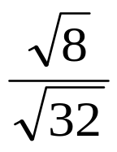

Solve and graph the following
2)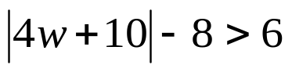

Reminder: The bell does not dismiss you, I dismiss you.
- Mr. Sabado

