Mr. Sabado, Algebra 1 Week 4 Wednesday, February 25, 2015

Home Practice

Due Today:
Assignment #12:
Functions

Due 2/26:
Assignment #13:
Functions

Quiz Friday!!!


Agenda

- Warm-Up
- HW Questions

- Review: Functions

- Class Work: Foxes and Rabbits

- Homework


Warm-Up
Simplify the following 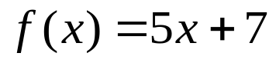
- 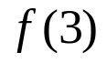
Find the value for x
- 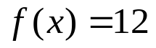
- 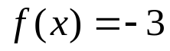`
` whs.saba.do

“It is never too late to be what you might have been.”
- G. Eliot

