Mr. Sabado, Algebra 1 Week 4 Thursday, February 26, 2015

Home Practice

Due Today:
Assignment #13:
Domain and Ranges

Due 2/27:
Assignment #14:
Function Notation

Quiz Friday!!!


Agenda

- Warm-Up
- HW Questions

- Review: Functions

- Class Work Continued: Foxes and Rabbits

- Homework


Warm-Up
State the domain and range of the following
- 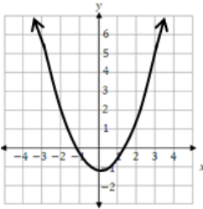
- ` whs.saba.do

“It is never too late to be what you might have been.”
- G. Eliot

