Mr. Sabado, Algebra 1 Week 6 Tuesday, March 10, 2015

Home Practice

Due Today:
Assignment #18:
p. 218 #3-15

Due 3/11:
Assignment #19:
Writing and Graphing Functions Worksheet pg. 21

Quiz Friday!!!


Agenda

- Warm-Up
- HW Questions

- Lesson: Part 1 & 2 Sorting Functions

- Class Work

- Homework

- Exit Ticket

Warm-Up

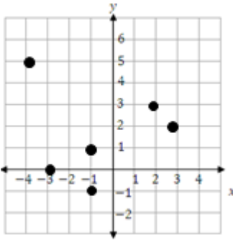
- What is the domain?

- What is the range?
1
whs.saba.do


“It is never too late to be what you might have been.”
- G. Eliot

