Mr. Sabado, Algebra 1 Week 6 Friday, March 13, 2015

Home Practice

Due Today:
Assignment #21:
What Could Make that Function? → Task 2 #1-6

Due 3/17:
E.C.:
Look What Followed Me Home, Ma!

Quiz Friday!!!


Agenda

- Warm-Up
- Turn in Opener Packet

- Quiz: Skill Quiz #6

- Quiet Activity

- Exit Ticket

- Return Graded Work

Warm-Up

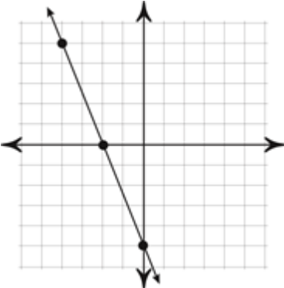

Using the graph above find:
- F(-4)
- F(x) =-5
1
whs.saba.do


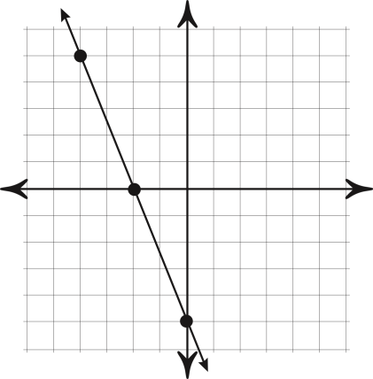

“It is never too late to be what you might have been.”
- G. Eliot
