Mr. Sabado, Algebra 1 Week 5 Monday, March 2, 2015

Home Practice

Due Today:
E.C:
Northern Native

Due 3/3:
Assignment #15:
Evaluating and Solving Review

Quiz Thursday!!!


Agenda

- Opener Sheet
- Warm-Up

- Clock Buddy Class Work: Solving Review

- Homework

- Quiet Activity

Warm-Up

Solve
1. 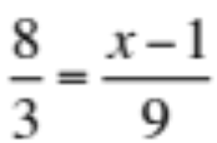

2. 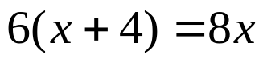
whs.saba.do


“It is never too late to be what you might have been.”
- G. Eliot

