Mr. Sabado, Algebra 1 Week 5 Tuesday, March 3, 2015

Home Practice

Due Today:
Assignment #15:
Evaluating and Solving Review

Due 3/4:
Assignment #16:
Crazy Running #1-7

Quiz Thursday!!!


Agenda

- Warm-Up
- HW Questions

- Lesson: Data Collection for Crazy Running

- Class Work

- Homework


Warm-Up

Graph the following
- 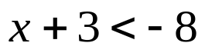

Solve
- 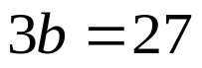
- 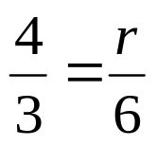
whs.saba.do

“It is never too late to be what you might have been.”
- G. Eliot

