Mr. Sabado, Algebra 1 Week 5 Wednesday, March 4, 2015

Home Practice

Due Today:
Assignment #16:
Crazy Running #1-7

Due 3/5:
Assignment #17:
Equations, Domain & Range Review

Quiz Thursday!!!


Agenda

- Warm-Up
- HW Questions

- Review: Order of Operations, Evaluating, Equations

- Class Work: Choose Your Fate

- Homework

Warm-Up

Solve
- 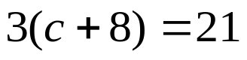

- 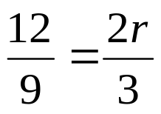
whs.saba.do


“It is never too late to be what you might have been.”
- G. Eliot

