Mr. Sabado, Algebra 1 Week 5 Thursday, March 5, 2015

Home Practice

Due Today:
Assignment #17:
Equations, Domain & Range Review

Due 3/9:
EC:
Purrsian Pet

Quiz Today!!!


Agenda

- Warm-Up
- HW Questions
- Turn in Opener Packet

- Meat-a-Morphosis

- Skill Quiz #5:

- Extra Credit

- Quiet Activity

Warm-Up

Determine if the following is a function. Explain your answer.
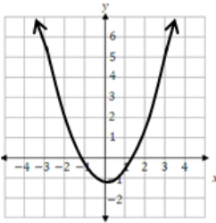 whs.saba.do


“It is never too late to be what you might have been.”
- G. Eliot

