Mr. Sabado, Algebra 1 Week 6 Monday, March 9, 2015

Home Practice

Due Today:
EC:
Purrsian Pet

Due 3/10:
Assignment #18:
p. 218 #3-15

Quiz Friday!!!


Agenda

- Pick up Opener
- Seating Chart
- Warm-Up

- Lesson: Part 1 Sorting Functions

- Homework

- Return Graded Work

Warm-Up

Simplify the following 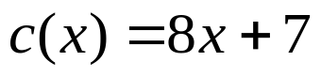
- 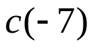
- 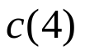
whs.saba.do


“It is never too late to be what you might have been.”
- G. Eliot

