Mr. Sabado, Algebra 2 Week 4 Friday, February 27, 2015

Home Practice

Due Today:
Assignment #15:
Rational Expression Review

Due 3/2:
Assignment #16:
Will Work For Brains


Agenda

- Warm-Up
- Turn in Packet

- Clock Buddy Class Work: Why Should I do my Homework?

- Homework

Warm-Up

Let f(x) = 4x and g(x) = x² + 3

- 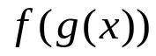

- 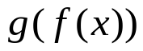
Solve
`whs.saba.do


If

“It is never too late to be what you might have been.”
- G. Eliot
Kaylee and tiffany are awesome ☺

