Mr. Sabado, Algebra 1 Week 5 Friday, October 3, 2014

Homework

Due Today:
- Assignment #20:
P. 36&37: Exponents and Roots Worksheet

Due 10/6:
- Assignment #21:
Activity 9 Worksheet

Bring your Textbook every day!!!
Quiz Friday!!!

Agenda

- Warm-Up
- Turn in Opener Packet

- Quiz: Roots and Exponents

- Quiet Activity

- Homework



Warm-Up

Simplify
- 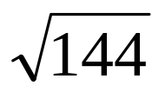

- 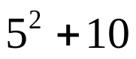

- 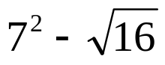

whs.saba.do

“It is never too late to be what you might have been.”
- G. Eliot
Nb

