Mr. Sabado, Algebra 1 Week 6 Tuesday, October 7, 2014

Homework

Due Today:
- Assignment #21:
Activity 9 Worksheet

Due 10/6:
- Assignment #22:
P. 45: 15-27, 33, 53-61

Bring your Textbook every day!!!
Quiz Friday!!!

Agenda

- Pick Up Opener Sheet
- Warm-Up

- Lesson: Properties of Real Numbers

- Class Work

- Homework



Warm-Up

Simplify
- 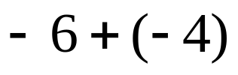

- 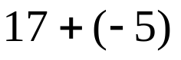

- 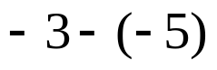

whs.saba.do

“It is never too late to be what you might have been.”
- G. Eliot
Nb

