Mr. Sabado, Algebra 2 Week 17 Monday, January 5, 2015

Homework

Due Today:
No HW

Due 1/6:
- Assignment #61
Factoring Review: What is the Title of this Picture?

Quiz on Friday!!!


Agenda

- Seating Chart
- Warm-Up

- Grade Quiz: Factoring Polynomials

- Class Work:

- Homework
- Return Graded Work

Warm-Up
Evaluate the following using synthetic substitution

- 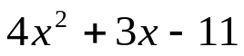 when x = - 3
- 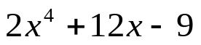 when x = - 2
- 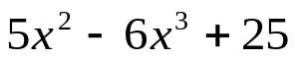 when x = 2
`whs.saba.do


“It is never too late to be what you might have been.”
- G. Eliot

