Mr. Sabado, Algebra 2 Week 16 Monday, December 15, 2014

Homework

Due Today:
- Assignment #56
Page 341: 3-10, 21-24, 37, 51-60

Due 12/16:
- Assignment #57
Page 349:
3-51 mult. of 3, 26, 65-72



Agenda

- Opener Sheet
- Warm-Up
- Turn in your Packet

- Lesson: Polynomial Operations

- Class Work

- Homework
- Return Graded Work

Warm-Up
Evaluate the following using synthetic substitution

- 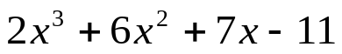 when x = - 8

- 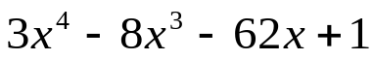 when x = 4


whs.saba.do

“It is never too late to be what you might have been.”
- G. Eliot

