Mr. Sabado, Algebra 2 Week 16 Tuesday, December 16, 2014

Homework

Due Today:
- Assignment #57
Page 349:
3-51 mult. of 3, 26, 65-72

Due 12/17:
- Assignment #58
Page 356: 3-17, 30-33, 51



Agenda

- Warm-Up
- HW Questions

- Lesson: Factoring Polynomials

- Class Work

- Homework
- Return Graded Work

Warm-Up
Evaluate the following using synthetic substitution

- 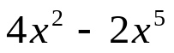 when x = - 3

Multiply
- 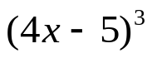


whs.saba.do

“It is never too late to be what you might have been.”
- G. Eliot

