Mr. Sabado, Algebra 2 Week 16 Wednesday, December 17, 2014

Homework

Due Today:
- Assignment #58
Page 356: 3-17, 30-33, 51

Due 12/18:
- Assignment #59
Page 357: 18-29, 36-41, 45-50
Quiz on Friday!!!


Agenda

- Warm-Up
- HW Questions

- Lesson: Factoring Polynomials

- Class Work

- Homework
- Return Graded Work

Warm-Up
Evaluate the following using synthetic substitution

- 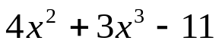 when x = - 3

Multiply
- 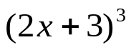


whs.saba.do

“It is never too late to be what you might have been.”
- G. Eliot

