Mr. Sabado, Algebra 2 Week 16 Thursday, December 18, 2014

Homework

Due Today:
- Assignment #59
Page 357: 18-29, 36-41, 45-50

Due 12/19:
- Assignment #60
5.4 Review Worksheet

Quiz on Friday!!!


Agenda

- Warm-Up
- HW Questions

- Lesson Continued: Factoring Polynomials

- Class Work

- Homework
- Return Graded Work

Warm-Up

Factor Completely
- 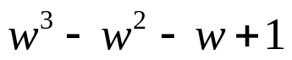

Multiply
- 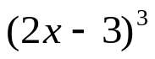


whs.saba.do

“It is never too late to be what you might have been.”
- G. Eliot

