Mr. Sabado, Algebra 2 Week 18 Thursday, June 4, 2015

Home Practice

Due Today:
Assignment #67:
Stats Review

Due 6/5:
Assignment #68:
p. 856: 3-27 odd, 30-34


Agenda

- Warm-Up

- Lesson: Right Triangles

- Class Work

- Homework

- Return Graded Work

Warm-Up

Determine the discriminant value and how many solutions.
1) 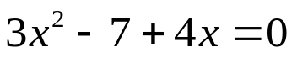

Simplify
2. 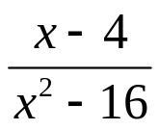

3. 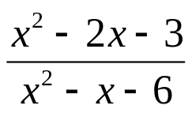
`whs.saba.do

+

If

“It is never too late to be what you might have been.”
- G. Eliot

