Mr. Sabado, Algebra 2 Week 19 Wednesday, January 11, 2017

Homework

Due Today:
Assignment #79
Unit 1 Review

Due 1/12
Assignment #80
Unit 2 Review



Agenda

- Warm-Up

- Class Work: Review

- Homework

- Extra Credit

- Return Graded Work

Warm-Up

Let r(x) = 4x +1 and s(x) = 7x

- 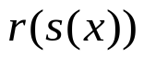

- 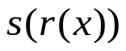

- 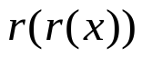
Find the inverse of
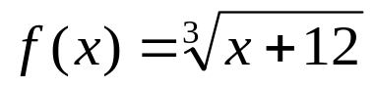

`



“It is never too late to be what you might have been.”
- G. Eliot

