Mr. Sabado, Algebra 2 Week 19 Friday, January 13, 2017

Homework

Due Today:
Assignment #81
Unit 3 Review

Due 1/17
-Assignment #82
Unit 4 Review
- Finals E.C Study Guide


Agenda

- Warm-Up

- Class Work: Finish Assignments for Week 19 Packet

- Homework

- Finals Study Guide

- Return Graded Work

Warm-Up

Solve
- 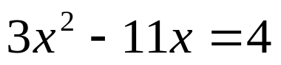

2. 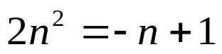

3. Simplify
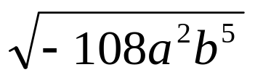





“It is never too late to be what you might have been.”
- G. Eliot

