Mr. Sabado, Algebra 2 Week 8 Thursday, October 13, 2016

Homework

Due Today:
- Assignment #33
p. 432 (3-37 odd, 36, 44, 48-53)

Due 10/14
- Assignment #34
p. 442: (3-13, 29, 31, 32, 34, 36)

Quiz on Friday!!!
Unit 2 Test 10/19 & 10/20

Agenda

- Warm-Up

- Lesson: Inverse Functions

- Class Work

- Homework

- Return Graded Work


Warm-Up

Let f(x) = 3x and g(x) = x + 3

- 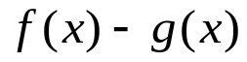

- 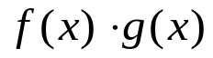

- 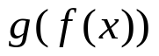
Solve
- 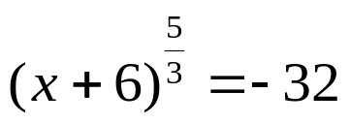



Reminder: The bell does not dismiss you, I dismiss you.
- Mr. Sabado

