29Mr. Sabado, Algebra 2 Week 8 Friday, October 14, 2016

Homework

Due Today:
- Assignment #34
p. 442: (3-13, 29, 31, 32, 34, 36)

Due 10/17
- Assignment #35
Inverse Functions Practice

Quiz on Friday!!!
Unit 2 Test 10/19 & 10/20

Agenda

- Warm-Up
- Turn in Opener Packet

- Quiz:

- Quiet Activity
- Homework

- Return Graded Work


Warm-Up

Let r(x) = 4x +1 and s(x) = 7x

- 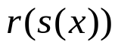

- 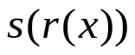

- 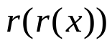

- Find the inverse of
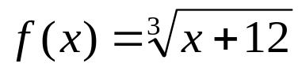


Reminder: The bell does not dismiss you, I dismiss you.
- Mr. Sabado

