Mr. Sabado, Algebra 2 Week 9 Monday, October 17, 2016

Homework

Due Today:
- Assignment #35
Inverse Functions Practice

Due 10/18
- Assignment #36
Unit 2 Review #1
- Assignment #37
Unit 2 Review #2

Unit 2 Test 10/19 & 10/20

Agenda
- Opener Sheet Warm-Up

- Unit 2 Test Review:

- Class Work

- Homework

- Return Graded Work


Warm-Up

Let g(x) = 5x - 6 and h(x) = 3x²
- 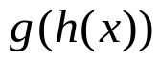

- 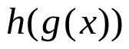

- 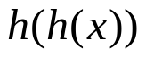
Find the inverse of
- 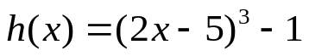



Reminder: The bell does not dismiss you, I dismiss you.
- Mr. Sabado

