Mr. Sabado, Algebra 2 Week 9 Tuesday, October 18, 2016

Homework

Due Today:
- Assignment #36
Unit 2 Review #1

Due 10/18
- Assignment #37
Unit 2 Review #2

Unit 2 Test
10/19: Calculator
10/20: No Calculator

Agenda

- Warm-Up

- HW Questions

- Return Quizzes

- Class Work

- Homework



Warm-Up

Solve
- 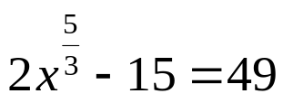

- 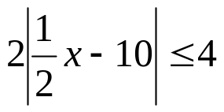

- 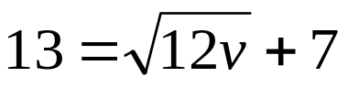



Reminder: The bell does not dismiss you, I dismiss you.
- Mr. Sabado

