Mr. Sabado, Algebra 2 Week 9 Friday, October 21, 2016

Homework

Due Today:
- Assignment #38
Cumulative Review Worksheet

Due 10/24
- Assignment #39
Quadratics Review Worksheet



Agenda

- Warm-Up

- Turn in Opener Packet

- Class Work: Elbow Partner

- Homework

Warm-Up

Find the area of the rectangle.
1. 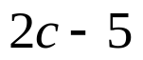
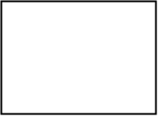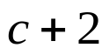

2. Solve
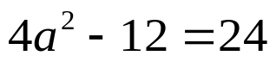



Reminder: The bell does not dismiss you, I dismiss you.
- Mr. Sabado

