Mr. Sabado, Algebra 2 Week 7 Friday, October 7, 2016

Homework

Due Today:
- Assignment #30
p. 1010 (19-27, 33-53 odd)
and
p.1015 (4-7, 12-23)

Due 10/11
- Assignment #31
p. 456 (23-31, 33, 75-80)

Quiz postponed to next Friday!!!

Agenda

- Warm-Up
- Turn in Packet
- Lesson: Solving Radical Equations

- Class Work

- Homework

- Return Graded Work



Warm-Up

Simplify the Following
- 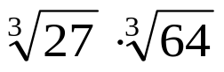

- 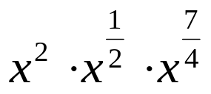
- 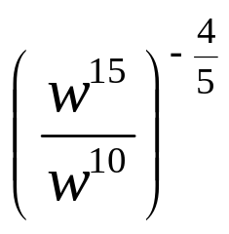


Reminder: The bell does not dismiss you, I dismiss you.
- Mr. Sabado

