Mr. Sabado, Algebra 2 Week 13 Wednesday, November 16, 2016

Homework

Due Today:
- Assignment #54
p. 304: (3-23 odd, 18)

Due 11/17
- Assignment #55
p. 312: (4-9, 15-17, 19-27 odd, 26)

- Assignment #56
Unit 3 Test Review

Unit 3 Quadratics Test
11/17: Solving
11/18: Graphing




Agenda

- Warm-Up

- Yesterday’s Handouts

- Class Work: Unit 3 Review

- Homework

- Return Graded Work

Warm-Up

- Write “Unit 3 Test Group Review”

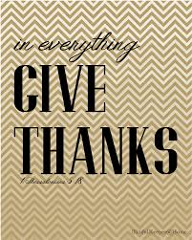

“It is never too late to be what you might have been.”
- G. Eliot

