Mr. Sabado, Algebra 2 Week 14 Monday, November 21, 2016

Homework

Due Today:
Assignment #57
Cumulative Review

Due 11/22
Assignment #58
Representational Fluency



Agenda

- Warm-Up

- Quadratics EC

- Class Work

- Homework

- Return Graded Work

Warm-Up

Simplify
- 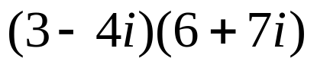
- Solve
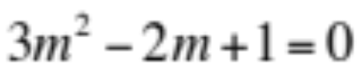
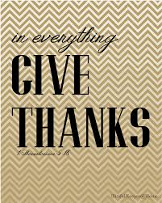

“It is never too late to be what you might have been.”
- G. Eliot

