Mr. Sabado, Algebra 2 Week 14 Tuesday, November 22, 2016

Homework

Due Today:
Assignment #58
Representational Fluency

Due 11/28
Assignment #59
Cubic Functions



Agenda

- Warm-Up

- Class Work

- Turn in Opener Packet

- Homework

- Return Graded Work

Warm-Up

Evaluate the following
- 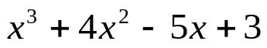 when x = - 4
2. Simplify
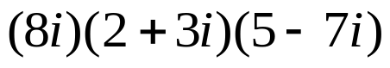
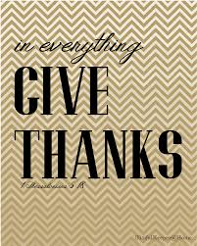

“It is never too late to be what you might have been.”
- G. Eliot

