Mr. Sabado, Algebra 2 Week 15 Monday, November 29, 2016

Homework

Due Today:
Assignment #59
Cubic Functions

Due 11/29
Assignment #60
p. 341 (3-8, 9-23 odd, 61-66)



Agenda

- Warm-Up
- HW Questions

- Lesson: Evaluating Polynomials

- Class Work

- Homework

- Return Graded Work

Warm-Up

Evaluate the following

- 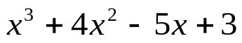 when x = - 6

- 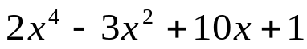 when x = 5


“It is never too late to be what you might have been.”
- G. Eliot

