Mr. Sabado, Algebra 2 Week 15 Tuesday, November 29, 2016

Homework

Due Today:
Assignment #60
p. 341 (3-8, 9-23 odd, 61-66)

Due 11/30
Assignment #61
What is a Polynomial?



Agenda

- Seating Chart
- Warm-Up
- HW Questions

- Lesson: Polynomial Operations

- Class Work

- Homework

- Return Graded Work

Warm-Up

Evaluate the following using synthetic substitution

- 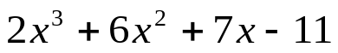 when x = - 8

- 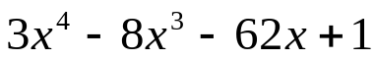 when x = 4


“It is never too late to be what you might have been.”
- G. Eliot

