Mr. Sabado, Algebra 2 Week 15 Wednesday, November 30, 2016

Homework

Due Today:
Assignment #61
What is a Polynomial?

Due 12/1
Assignment #62
Factoring Polynomials



Agenda

- Warm-Up
- HW Questions

- Lesson: Factoring Polynomials

- Exit Ticket

- Homework

- Return Graded Work

Warm-Up

Evaluate the following using synthetic substitution

- 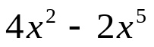 when x = - 3



“It is never too late to be what you might have been.”
- G. Eliot

