Mr. Sabado, Algebra 2 Week 15 Thursday, December 1, 2016

Homework

Due Today:
Assignment #62
Factoring Polynomials

Due 12/2
Assignment #63
Factoring Polynomials Patterns

Quiz Tomorrow (12/2)!



Agenda

- Warm-Up

- Lesson: Factoring Polynomials

- Math Sprint

- Homework

- Return Graded Work

Warm-Up

Factor Completely
- 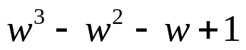

Multiply
- 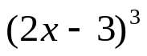



“It is never too late to be what you might have been.”
- G. Eliot

