Mr. Sabado, Algebra 2 Week 16 Monday, December 12, 2016

Homework

Due Today:
Assignment #69
Rational Zero Theorem Part 2

Due 12/13
Assignment #70
Solving Polynomials Review



Agenda

- Warm-Up

Review:
Remainder Theorem

- Class Work

- Homework

- Return Graded Work

Warm-Up

List the possible zeroes for

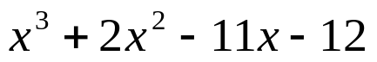

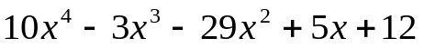

`



“It is never too late to be what you might have been.”
- G. Eliot

