Mr. Sabado, Algebra 2 Week 18 Tuesday, January 3, 2017

Homework

Due Today:
- No HW

Due 1/4
Assignment #74
Graphing Polynomials

Unit Test 1/5/17

WSKRK, YNEAD

Agenda

- Warm-Up

- Class Work:
TQ8JN

- Homework

- Return Graded Work

Warm-Up

Multiply

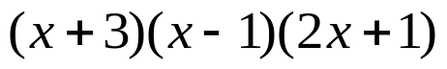

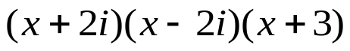

`



“It is never too late to be what you might have been.”
- G. Eliot

