Mr. Sabado, Algebra 2 Week 18 Wednesday, January 4, 2017

Homework

Due Today:
Assignment #74
Graphing Polynomials

Due 1/5
Assignment #75
Graphing Polynomials

Unit Test postponed to 1/10/17

WSKRK, YNEAD, TQ8JN

Agenda

- Warm-Up

- Lesson: Graphing Polynomials

- Class Work

- Homework

- Return Graded Work

Warm-Up

Factor the polynomial completely
- 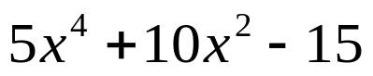
` Evaluate the following
- 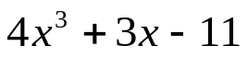 when x = - 2

`



“It is never too late to be what you might have been.”
- G. Eliot

