Mr. Sabado, Math 3 Week 2 Thursday, August 31, 2017

Homework

Due Today:
- Assignment #4
Functions

Due 9/1:
- Assignment #5
Representational Fluency Packet

Agenda

- Warm-Up

- HW Check

- Elbow Partner Classwork: Fluency

- Homework

- Practice Dismissal

Warm-Up
Graph the following:
- 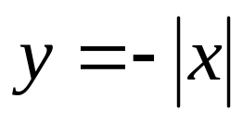

2. 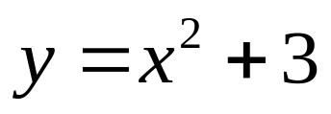

whs.saba.do



“It is never too late to be what you might have been.”
- G. Eliot

