Mr. Sabado, Math 3 Week 2 Friday, September 1, 2017

Homework

Due Today:
- Assignment #5
Representational Fluency Packet

Due 9/5:
- Assignment #6
Transformations

Agenda

- Warm-Up

- Turn in Opener Packet

- Group Classwork: Graphing Transformations

- Homework

- Practice Dismissal

Warm-Up
Graph the parent function and its transformation:
1. 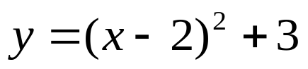
whs.saba.do



“It is never too late to be what you might have been.”
- G. Eliot

