Mr. Sabado, Math 3 Week 3 Tuesday, September 5, 2017

Homework

Due Today:
- Assignment #6
Transformations

Due 9/6:
- Assignment #7
Match My Function

Agenda

- Warm-Up

- Classwork: Match My Function

- Exit Ticket

- Practice Dismissal

Warm-Up
Graph the parent function and its transformation:
1. 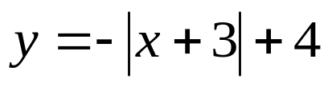
whs.saba.do



“It is never too late to be what you might have been.”
- G. Eliot

