Mr. Sabado, Algebra 2 Week 3 Thursday, September 8, 2016

Homework

Due Today:
- Assignment #11: Function Families:
Add Intervals of Increase, Decrease, Max, & Min

Due 9/9:
- Assignment #12: Function Families:
Add End Behavior

Quiz on Friday!!!

Agenda

- Warm-Up
- HW Questions

- Lesson: End Behavior

- Class Work

- Homework

Warm-Up
Determine the Intervals in increase, decrease, max, and min of :
- 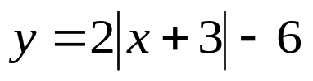
2. 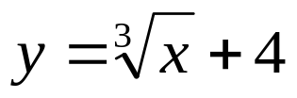

whs.saba.do



Reminder: The bell does not dismiss you, I dismiss you.
- Mr. Sabado

