Mr. Sabado, Algebra 1 Week 9 Friday, October 31, 2014

Homework

Due Today:
- Assignment #38:
Quiz Review Handout

Due 11/3:
- Assignment #39:
“What do you get when you…” Handout

Quiz Today!!!

Agenda

- Warm-Up
- HW Questions
- Turn in Opener Packet

- Quiz #6: Solving Multi-Step Equations

- Homework
- Return Graded Work



Warm-Up

Solve

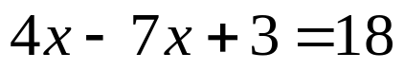

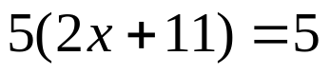


whs.saba.do

“It is never too late to be what you might have been.”
- G. Eliot

